|  |  |  |  |  |  |
| --- | --- | --- | --- | --- | --- |
| |  | | --- | | **Генконсульство России в г. Карачи, Пакистан** | | | Thu, 12 Sept, 12:33 (8 days ago) |  | https://mail.google.com/mail/u/1/images/cleardot.gif  https://mail.google.com/mail/u/1/images/cleardot.gif  https://mail.google.com/mail/u/1/images/cleardot.gif |
| |  | | --- | | to me  https://mail.google.com/mail/u/1/images/cleardot.gif | | | | |
| from: | **Генконсульство России в г. Карачи, Пакистан** <karachi@mid.ru> |
| to: | eliyasyedaliabbaspaul@gmail.com |
| date: | 12 Sept 2024, 12:33 |
| mailed-by: | mid.ru |
| Signed by: | mid.ru |
| security: | https://mail.google.com/mail/u/1/images/cleardot.gif Standard encryption (TLS) [Learn more](https://support.google.com/mail?hl=en-GB&p=tls&authuser=1) |
| https://ssl.gstatic.com/ui/v1/icons/mail/images/cleardot.gif: | Important according to Google magic. |
|  | |

Dear Sir/Madam,

Please kindly notice that in execution of the Decree issued by the President of Russia Vladimir Putin, the list of the countries that are eligible for this program is to be published soon.

The information on whether Pakistan is included in this list will be put on our official Facebook page and website ([karachi.mid.ru/en](http://karachi.mid.ru/en)).

Regards,

________________________________________________________________

Consulate General of the Russian Federation in Karachi, Islamic Republic of Pakistan

Plot No. FL 1, Block-4, Scheme 5, Clifton, Karachi

Tel.: (0092-21) 358-61-336, 3583-03-22

E-mail: [rfconsul@gmail.com](mailto:rfconsul@gmail.com)

Web: [www.rusconsulkarachi.mid.ru](http://www.rusconsulkarachi.mid.ru/) (available in English and Urdu versions)

Visa Application Letter of Shared Value Visa Russia (please Reply Must). Please issue the list of eligible countries so that I can apply for the shared value visa along with my family

Dear High Commission of Russia Russian Embassy Islamabad Pakistan Dated: 07-09-2024

Subject: Request for Shared Value Visa Of Great Russia, Resettlement, Justice, Relief in Russia, Refuge Asylum, A Job in Russia, at UNHCR in Russia, Russian Citizenship as soon as possible due to Religious Persecution in Pakistan

Dear Higher Commissioner Ambassador of Russia His Excellency Vladimir Putin

Honorable Respected Sir,

My name is Paul Eliya and I want to Permanently shift to Russia for saving my life because Pakistan verbally accuses me for committing Blasphemy Desecration u/s 154 crPC 295-A-B-C

<https://youtu.be/hSrLOBphJgU?si=Zva2CgTlLUQm3wU1>

against Quran Islam Prophet his companions and High Treason against Pakistan and declared me as psycho mad mentally unstable Disturbed person having dangerous intentions and capabilities and during this all process of Conspiracies and Propaganda against me Pakistan Looted and Stolen my 5 Billion Dollars Properties and hijacked my all fundamental human rights but i have my Valid Passport# LL1019803 I also have my medical certificate and Police Verification Certificate and my CNIC# is 37405-0365980-9. It will be a Great Great Honour for me to Join Russian-Indian Air Force as A Fighter Pilot it is like a Dream come true, my Fundamental human rights have been Hijacked and I want to immigrate to Russia because i am facing Religious Persecution Discrimination with No Religious Freedom in Pakistan. The Accused Criminal Terrorist Bad Pakistan Army ISI is involved in All Sins Crimes against me. I love My Leaders Shri Shri Imran Khan Gee and Shri Vladimir Putin Gee and their Nations unconditionally by loving them serving them unconditionally through my this very website [Https://istheonlywayjesusc.wixsite.com/soul](https://istheonlywayjesusc.wixsite.com/soul)

<Https://istheonlywayjesusc.wixsite.com/russian>

<Https://istheonlywayjesusc.wixsite.com/indian>

And Pakistan Tehreek e Insaaf of Courageous Knowledgeable Eternal Soul Imran Khan will give me Justice because I am a Syed Shia Jewish Christian Israeli Sanatani origin Christian Paul Eliya.

ME AND MY FAMILY URGENTLY NEED MONEY TO BUY FOOD AND ENERGY FOR THE TIME BEING WE ARE IN PAKISTAN TO SURVIVE TILL WE GO TO RUSSIA AND WE WILL NOT BE A BURDEN ON RUSSIA BUT WE WILL SERVE RUSSIA WITH LOVE AND  WITH OUR HARDWORK OF OUR TALENTS IN THE BEST INTERESTS OF THE BELOVED PEOPLE OF BELOVED RUSSIA FOR ALL THE WORLD

I LOVE RUSSIA UNCONDITIONALLY AND PLEASE ISSUE THE LIST OF COUNTRIES SO THAT WE CAN APPLY FOR THE SHARED VALUE VISA ALONG WITH MY FAMILY OF 7 FAMILY MEMBERS FOR SAVING OUR REMAINING LIVES BREATHS LEFT WITHIN US IN HOPE OF THIS SHARED VALUE VISA THANK YOU MY HERO VLADIMIR PUTIN, I WILL ONLY LIVE IN RUSSIA AND WILL NEVER LEAVE MY BELOVED FRIEND MY BELOVED LOVED ONES RUSSIAN PEOPLE TILL MY LAST BREATH I WILL SERVE, LOVE AND PROTECT RUSSIA AS MY DUTY AND MY JOB BECAUSE IN MY HARD TIMES BELOVED RUSSIA AND BELOVED INDIA WITHSTAND WITH ME AND I CAN EVEN SACRIFICE MY LIFE FOR MY BELOVED RUSSIA.

In Pakistan I have no money to travel and I am very very Vulnerable because I am facing Mob Lynching and Systematic Persecution through State Sponsored Entities, but I hope that World is supporting me through interception they are also trying to give me Justice regarding the following matters due to my Christian Religion Beliefs and my Freedom of Expression Political opinions and my Good Works for all Humanity in my Website [Https://istheonlywayjesusc.wixsite.com/love](https://istheonlywayjesusc.wixsite.com/love)

* Request for Financial Help from only Good Pakistan Army urgently and Repossession of Properties and 10 Kanal Sangjani land 808-5A 17-12-2020 Thana Tarnol Police Station and others are in process Blasphemy Case Treason Case at the Pakistan Army Centre 051-111-130-786 in process PMS#24530-10588-8010. PAN AM Claim and Steel Mill Investment Recovery, Other Plots Lands
* Allotment of Government Plot of 14 Marlas Entitled to my Father Hassan Syed from FGEHA Islamabad in Sector F-14,15,12 etc AND OFFICIAL TRANSPORT PETROL ENTITLEMENT CLAIMS EDUCATION CLAIMS OF 8 CRORE FROM MINISTRY OF COMMUNICATION NATIONAL TRANSPORT RESEARCH CENTRE
* A Safe Passage to India for me and for my family or to any Christian Country [Https://istheonlywayjesusc.wixsite.com/love](https://istheonlywayjesusc.wixsite.com/love)
* May Lord Jesus Christ Take us to any Safe Country for saving and Eternally Living our Lives in Jesus Christ Forever through our Souls of Love Amen
* My Parents and Family can join me later on and I am also a great Great Fan of Of My Hero Shri Vladimir Putin a Very Good Soul of Jesus Christ Courageously Knowledgeable Eternal Life of God with his Beloved ones

Regards

Pastor Paul Eliya and Christian Family loves and serves all Human Beings unconditionally

House #96 lane no 4 block d sector 4 airport housing society Rawalpindi 03145550432 03185309511

Email Id: [eliyasyedaliabbaspaul@gmail.com](mailto:eliyasyedaliabbaspaul@gmail.com)

I have all the Evidences that I have shared with the world for Justice <https://istheonlywayjesusc.wixsite.com/jesuschrist>

|  |  |
| --- | --- |
| from: | Syed Ali Abbas Paul Eliya <eliyasyedaliabbaspaul@gmail.com> |
| to: | "Генконсульство России в г. Карачи, Пакистан" <karachi@mid.ru> |
| cc: | karachi@mid.ru, islamabad@dks.ru, pakistan@mid.ru |
| bcc: | contact@majorgauravarya.com |
| date: | 14 Sept 2024, 09:49 |
| subject: | Re: |
| mailed-by: | gmail.com |
|  | |

https://ssl.gstatic.com/ui/v1/icons/mail/images/cleardot.gif

On Sat, 14 Sept 2024, 9:46 am Syed Ali Abbas Paul Eliya, <[eliyasyedaliabbaspaul@gmail.com](mailto:eliyasyedaliabbaspaul@gmail.com)> wrote:

Thank You Very Much for Replying, I am Applying for The Shared Value Visa Via this email  
Because I am facing Religious Persecution in Pakistan, Pakistan has stolen my Properties and deprived me from my Fundamental human rights, me and my family are facing a Direct threat of Blasphemy Laws Mob Lynching so I am very Very Vulnerable in Pakistan, please Help me my CNIC# is 37405-0365980-9 Passport # LL1019803.i have no money to survive in Pakistan.  
I love Russia and its Culture Unconditionally  
[Https://istheonlywayjesusc.wixsite.com/soul](https://istheonlywayjesusc.wixsite.com/soul)

Regards  
Pastor Paul Eliya and Christian Family  
+92-314-555-0432  
+92-318-530-9511  
House#96, lane#4, block D, sector 4 airport housing society Rawalpindi 46000

On Thu, 12 Sept 2024, 12:33 pm Генконсульство России в г. Карачи, Пакистан, <[karachi@mid.ru](mailto:karachi@mid.ru)> wrote:

Dear Sir/Madam,

Please kindly notice that in execution of the Decree issued by the President of Russia Vladimir Putin, the list of the countries that are eligible for this program is to be published soon.

The information on whether Pakistan is included in this list will be put on our official Facebook page and website ([karachi.mid.ru/en](http://karachi.mid.ru/en)).

Regards,

________________________________________________________________

Consulate General of the Russian Federation in Karachi, Islamic Republic of Pakistan

Plot No. FL [1, Block-4](https://www.google.com/maps/search/1,+Block-4?entry=gmail&source=g), Scheme [5,](https://www.google.com/maps/search/5,+Clifton,+Karachi?entry=gmail&source=g) [Clifton, Karachi](https://www.google.com/maps/search/5,+Clifton,+Karachi?entry=gmail&source=g)

Tel.: (0092-21) 358-61-336, 3583-03-22

E-mail: [rfconsul@gmail.com](mailto:rfconsul@gmail.com)

Web: [www.rusconsulkarachi.mid.ru](http://www.rusconsulkarachi.mid.ru/) (available in English and Urdu versions)

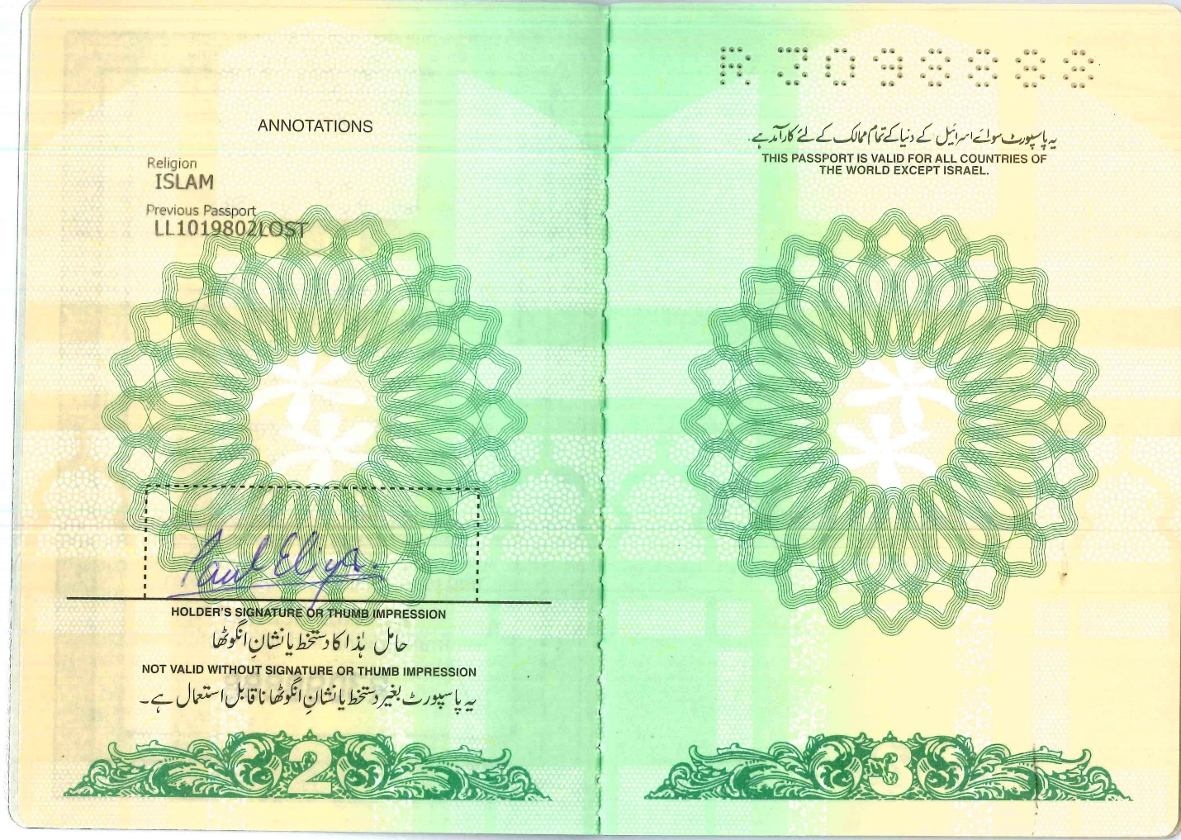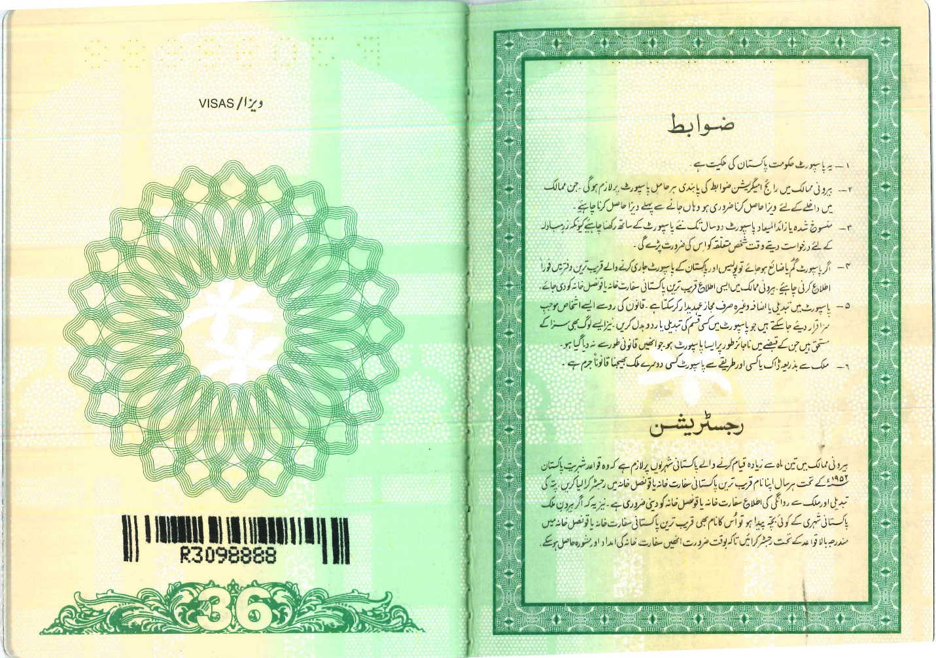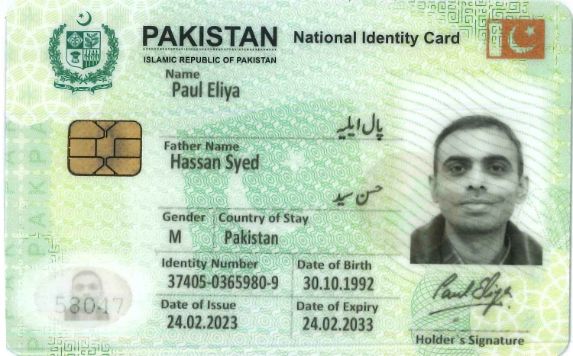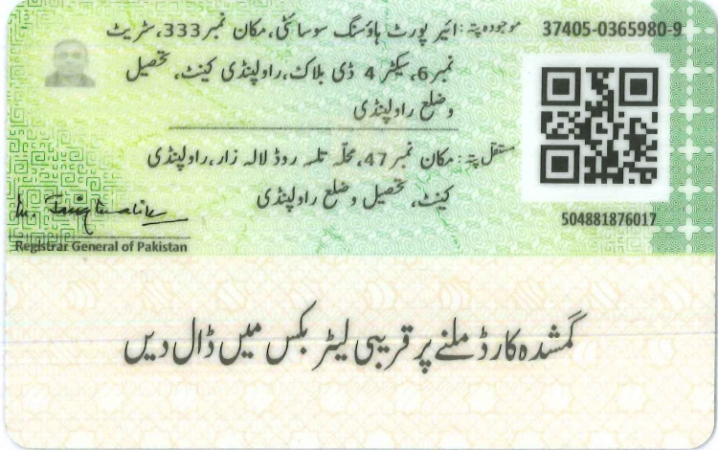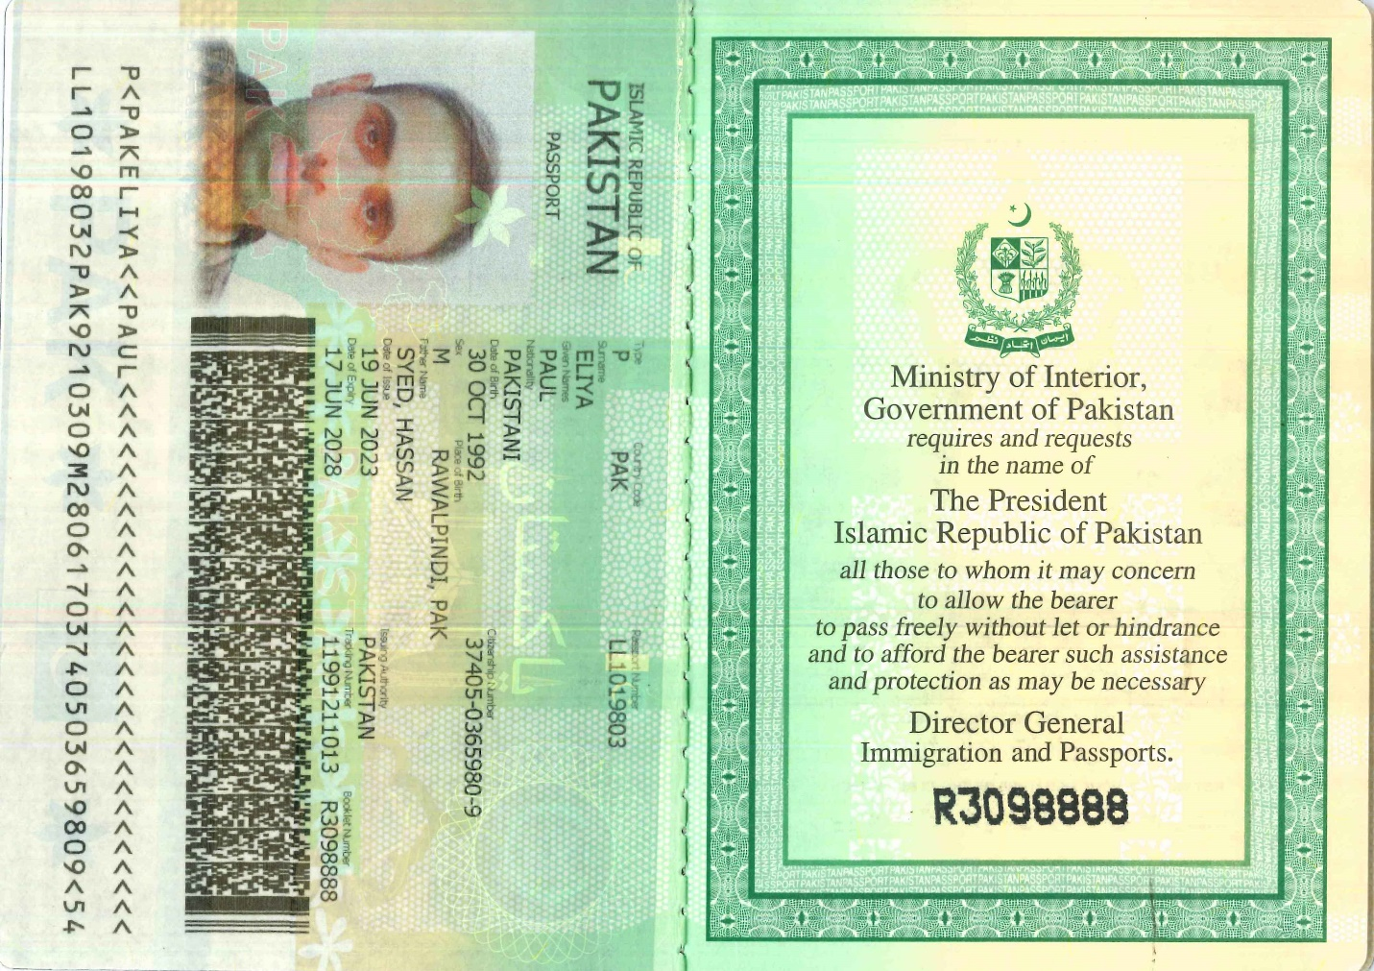

KIND REMINDER AND LATEST UPDATES IF ANY REGARDING THE RUSSIA APPLICATION ATTACHED REGARDING THE SHARED VALUE VISA LIST OF ELIGIBLE COUNTRIES because ALL GOOD HUMAN BEINGS ARE ELIGIBLE FOR THEIR FUNDAMENTAL HUMAN RIGHTS